**Treasure Caverns of Doom**

**Project Documentation**

1. **Flowchart of the entire game structure**

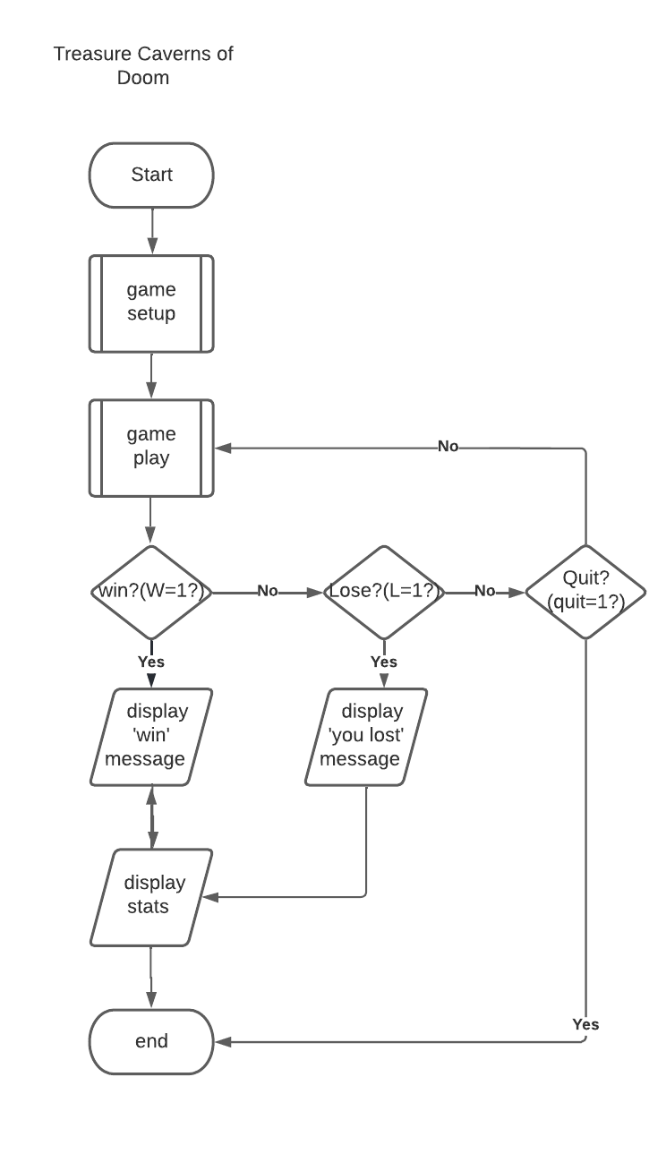

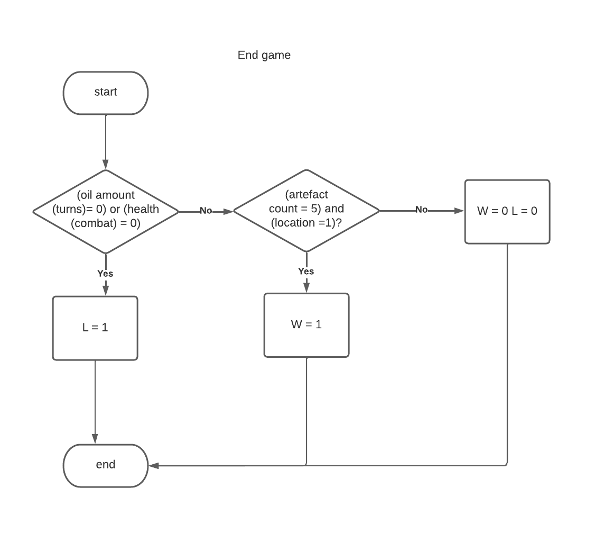

1. **Project Test Plan**

|  |  |  |  |  |
| --- | --- | --- | --- | --- |
| **Class** | **Function** | **Description** | **Expected Result** | **Actual Result** |
| Player | Player() | The constructor for assigning initial attribute values | Assigning all the initial values to the relevant attribute | As expected |
|  | assignName() | Assign a name which is requested at the start of the game | Assigning the name input by the player to ‘name’ attribute | As expected |
|  | updateStats() | Update the given player statistics | Update the statistics of the player if something changed | As expected |
|  | displayStats() | Display player statistics | Display the statistics of the player if required | As expected |
|  | updateAttribute() | Update the given player attribute | Update the attributes of the player if something changed | As expected |
|  | displayAttribute() | Display the given player attribute | Display the attributes of the player if required | As expected |
| Monster | Monster() | The constructor for assigning initial attribute values | Assigning all the initial values to the relevant attribute | As expected |
|  | placeLocation() | Place the monster in a randomly assigned location | Randomly assigned a location to monster and update the relevant attribute | As expected |
|  | assignItem() | Assign an item randomly | Randomly assigned an item to monster and update the relevant attribute | As expected |
|  | startCombat() | Start a combat | Run combat sequence scenario | As expected |
| Dragon | performFire() | Breath fire which it may use once during combat | Breath fire during a combat | As expected |
| Location | Location() | The constructor for assigning initial attribute values | Assigning all the initial values to the relevant attribute | As expected |
|  | displayData() | Display data about a monster or item if it is in the player’s current location | If a monster is in the player’s current location, display data of the monster to the player | As expected |
|  | updateDisplayData() | Update the display data when an item or monster is removed from the player’s current location | If a monster is removed from the player’s current location update the details | As expected |
|  | displayRequiredData() | Display all appropriate information when the player enters it | Display details of attributes of the location if required | As expected |
| Item | Item() | The constructor for assigning initial attribute values | Assigning all the initial values to the relevant attribute | As expected |
|  | placeLocation() | Place the item in a randomly assigned location | Randomly assigned a location to item and update the relevant attribute | As expected |
|  | displayName() | Displays its name or type when it appears in the current player location | If an item is in the player’s current location, display data of the item to the player | As expected |
|  | makeUsable() | Make an item usable when its uses are not reduced to zero or less | Make an item usable when possible | As expected |

|  |  |  |  |  |
| --- | --- | --- | --- | --- |
| **Scenario** | **Function** | **Description** | **Expected Result** | **Actual Result** |
| Selecting an option | pressX() | Command to examine a cavern | Examine a cavern and find out items or artefacts | As expected |
|  | pressA() | Command to attack a monster | Attack a monster and starts a combat | As expected |
|  | pressF() | Command to flee a battle | Flee a battle | As expected |
|  | pressT() | Command to take an item | Take an item | As expected |
|  | pressD() | Command to drop an item | Drop an item | As expected |
| Combat sequence | playerAttack() | Calculate the player’s attack value | Return the player’s attack value | As expected |
|  | monsterAttack() | Calculate the monster’s attack value | Return the monster’s attack value | As expected |
|  | updateMonsterHealth() | Update the health of the monster | If the player’s attack value is greater than the monster’s attack value  calculate damage as player’s damage value minus monster’s defense and  subtract points equal to the damage inflicted from the monster health | As expected |
|  | updatePlayerHealth() | Update the health of the player | If the monster’s attack value is greater than the player’s attack value calculate damage as monster’s damage value minus player’s defense  subtract points equal to the damage inflicted from the player health | As expected |
| End game conditions | win() | Display “The player wins” | Display as winner if player successfully collect all the artefacts | As expected |
|  | lose() | Display “The player loses” | Display as looser if player’s lantern runs out of oil, or player run out of health | As expected |

1. **Description of “How to Play”**

Five artefacts are hidden in the Treasure Caverns of Doom by the great wizard Balthazar many centuries ago. Your task is to find these five artefacts and collect them by referring to the map.

In the game, you may find twenty smaller caverns that make up the underground cavern known as The Treasure Caverns. Three tunnels connect each cavern to the others. The above-mentioned five artefacts are hidden in five caverns out of twenty. But unfortunately, the artefacts are guarded by monsters who challenge anyone they meet to combat. There is a Dragon among these monsters which guards the most valuable artefact. You have to first find out the other four artefacts before facing the dragon.

When you enter the cavern, you will have a map, and a lantern that has a limited amount of oil which also sets the number of turns you have, you are armed with a sword and have a backpack with some provisions. Each turn, you may move to an adjacent cave, or do one or more of the other actions available to you.

When you enter a cave, you can examine it and find the artefacts in the cave. Although the main target is to find five artefacts, you can collect items such as coins and gems too. Then you can sell them and make money when you return to the village. While you are examining the cave if you find out a monster then you can attack it or flee from the battle. If you get damage while combating a monster you can move on to the next cavern heading down one of the visible exits.

Finally, if you are able to successfully collect all the artefacts and escape the caverns you win. If your lantern runs out of oil or you run out of health, you lose. Therefore, try to avoid these things.

Good luck!

Commands

[X] – Examine a cavern

[A] – Attack a monster

[F] – Flee a battle

[P] – Collect Provisions

[T] – Take an Item

[D] – Drop an Item

[N] – Moves North

[S] – Moves South

[W] – Moves West

[E] – Moves East

1. **UML Diagrams**

1. **Map of your Game Environment**

